|  |  |  |  |  |  |  |  |  |  |  |  |  |  |  |  |  |  |  |  |  |  |  |  |  |
| --- | --- | --- | --- | --- | --- | --- | --- | --- | --- | --- | --- | --- | --- | --- | --- | --- | --- | --- | --- | --- | --- | --- | --- | --- |
| ST Electronics (Info-Software Systems) Pte Ltd  (*Regn No: 198601030N*)  NUS  Out-of-Office Setup Process and Design Document  The information contained herein is the property of ST Electronics (Info-Software Systems) Pte Ltd and may not be copied, used or disclosed in whole or in part to any third party except with written approval of ST Electronics (Info-Software Systems) Pte Ltd or, if it has been authorized under a contract.   |  |  |  |  | | --- | --- | --- | --- | |  | **Name** | **Designation/Dept** | **Signature** | | Prepared By: | James Wong / Jason Tan | Technical Manager / LIS |  | | Reviewed By: | Linda Low | Project Manager / LIS |  | | Approved By: | Malcom Tay | Director / NUS |  |  |  |  | | --- | --- | | Revision : 1.1 | Copy Number : _ of N | | Document ID : | Date of Issue : | | File name : OOOProcessModelDesign.doc | Total Number of Pages : |  |  |  | | --- | --- | | NUS |  | |

DISTRIBUTION LIST

|  |  |
| --- | --- |
| **Copy Number** | **Name** |
| 01 | Project Library |
| 02 | NUS |

AMENDMENTS RECORD

|  |  |  |  |  |
| --- | --- | --- | --- | --- |
| Revision No. | Affected Page(s) | Details of Change  (if necessary) | CP/DCR No.  (where applicable) | Date of Implementation |
| 1.0 | All | New Creation | - | 05-05-2015 |
| 1.1 | All | Adjusted formatting, added wireframe |  | 12-05-2015 |
| 1.2 | Schedule and Timeline | Updated the activity performed during the requirement and clarification |  | 12-05-2015 |
| 1.3 | Wireframe of Out-of-Office User Interface | NUS to provide the necessary screen dimensions along with pixel size, fonts and any other details on screen UI |  | 12-05-2015 |
|  |  |  |  |  |
|  |  |  |  |  |
|  |  |  |  |  |
|  |  |  |  |  |
|  |  |  |  |  |
|  |  |  |  |  |
|  |  |  |  |  |
|  |  |  |  |  |
|  |  |  |  |  |
|  |  |  |  |  |
|  |  |  |  |  |
|  |  |  |  |  |
|  |  |  |  |  |
|  |  |  |  |  |
|  |  |  |  |  |
|  |  |  |  |  |
|  |  |  |  |  |
|  |  |  |  |  |
|  |  |  |  |  |
|  |  |  |  |  |
|  |  |  |  |  |
|  |  |  |  |  |

TABLE OF CONTENTS

Out-of-Office Requirement Description 5

Customization Description 5

Assumptions 5

Schedule and Timeline 6

Wireframe of Out-of-Office User Interface 6

Out-of-Office-Setup Collapsed Process Model 10

Out-of-Office-Setup Expanded Process Model 11

Details of activities in the Process Model 12

1. Set-up Out of Office Message & Delegate Tasks 12

1.1. Enable Out of Office Set-up 12

1.1.1. Input Out of Office Settings 12

1.1.2. Store OOO Settings 12

1.1.3. Delegate Tasks to Back-up Resources 12

1.1.4. Find Roles 12

1.1.5. Verify Summary 13

1.1.6. Summary State 13

1.1.7. Store back-up delegations 13

1.1.8. Find Back-up Resources 13

2. Actual Delegation of tasks to back-up 13

2.1. Delegate Tasks to Back-up in a BPD 13

2.1.1. Find current delegation 13

2.1.2. Is delegated person OOO? 14

2.1.3. Allocate tasks to back-up 14

2.1.4. Email Original User 14

2.1.5. Max. level of delegations exceeded? 14

2.1.6. Process Default (No additional action) 14

2.1.7. Find next level delegation 14

2.2. Wait for end date of OOO 14

3. Delegate back to the Original User 15

3.1. Restore delegation to original user 15

3.2. Email Summary to Original User 15

3.3. User edits end date to current date 15

Glossary 16

Participants, Business Owners, Experts 16

Inputs, Outputs 16

# Out-of-Office Requirement Description

The high level requirements for the Out-of-Office component are:

1. Allow users to set Out of Office (OOF) status

Parameters required:

1. Start date & time
2. End date & time
3. OOF Message
4. Allow Out of Office users to assign delegated persons to take over task assignments

Perimeters required:

1. Current roles
2. Backup roles (selection list of persons)
3. Package Out-of-Office component as a toolkit component for reusability

# Customization Description

1. Process Portal to have a custom page / widget / popup to define OOF
2. The OOF delegates will default to "Process Default", which is a flag to indicate bypassing of the OOF delegate component. All routing in this case will be handled internally by the process design.
3. As part of OOF submission, for each role that the user is involved, allow user A to choose a person for delegation from corresponding backup role
4. As part of OOF submission, user is able to configure role/s to be delegated to a specific named delegate read off AD instead of the list from the backup roles
5. On all delegation selections completed, there will be a summary page for users to verify delegations before submission to system for configuration
6. Create component / process for routing of task to delegated person if user is OOF
7. If task to OOF user A, route to delegated person B
8. If delegated person eg B also OOF, route to B's delegated person which is C
9. On successful reassignment of task to delegated user eg B, system must send an email notification back to original task owner eg A, for notification of reassignment of task.
10. Configurable forward delegation maximum limit
11. On end of user OOF period, there will be a summary email sent to user and database record on all the tasks that were reassigned by the system for the particular user.
12. Component or process to be included in toolkit for reuse

# Assumptions

1. BPM must be able to get Users from AD through AD Sync.
2. Roles will be created and managed manually in BPM, including membership
3. Human Tasks must be assigned to the roles created
4. Roles will be created with a “_bkup” suffix to identify as backup to the main role used in task assignment role
5. User OOF settings will be accessible from user’s BPM Portal homepage
6. Persons eligible for delegation will be selected from list in backup roles provisioned. Alternatively, there will be an option for users to choose a specific delegate within the AD.

# Schedule and Timeline

Estimated timeline:

* 4 – 11 May Requirement Gathering and Clarification
* 12 May – Design documents submission to NUS for approval
* 13 May – Commencement of development
* 13 May – 5 June – Implementation
* 8 - 11 June
* 12 June – SIT summary report and Verification of Environment
* 13 June – Deployment on UAT environment and perform sanity testing.
* 14 -15 Jun –Acceptance testing (NUS)
* 18 Jun – Production ready

# Wireframe of Out-of-Office User Interface

Thisfollowing figures show the wireframes of the UI components to be used by users for their Out of Office settings. The designs are approximates and may not fully represent the end delivery.

Assumption: Customer should provide the screen resolution with pixels, fonts and any other information with respect to screens UI.

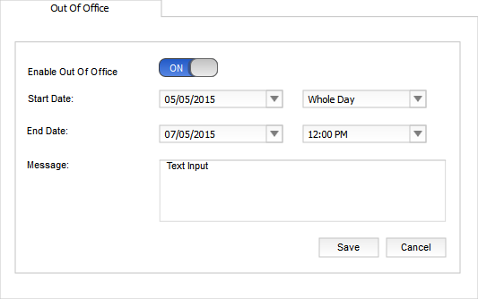

Figure 1 Out of Office Tab

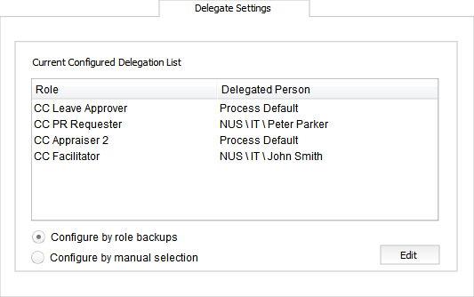

Figure 2 Current Configured Delegate Settings Tab

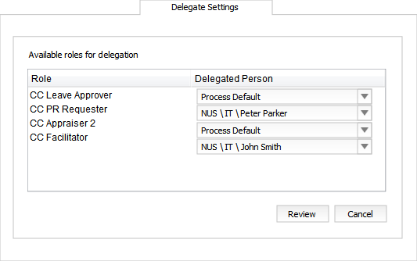

Figure 3 Role-based Delegation Configuration

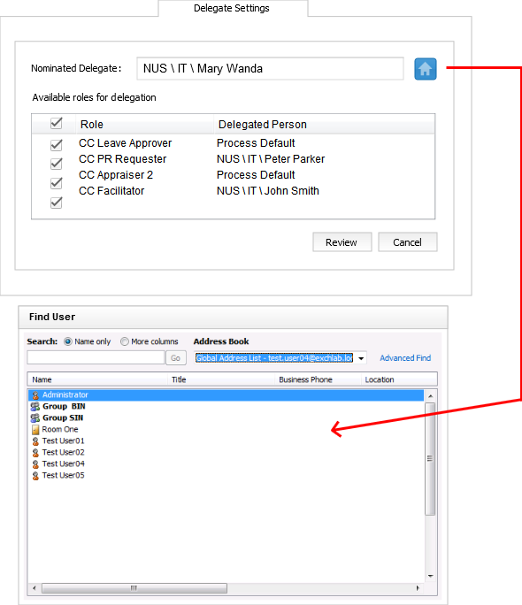

Figure 4 Manual Delegation Configuration

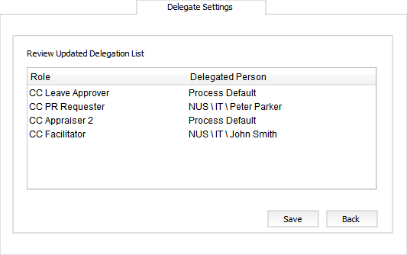

Figure 5 Review Delegation Configurations

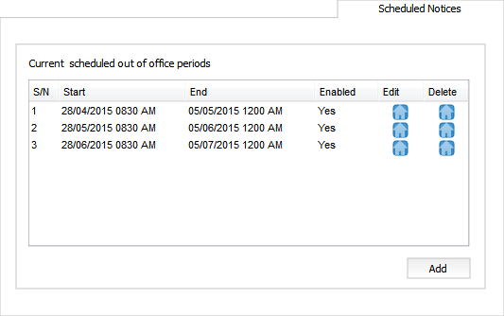

Figure 6 Scheduled Notices Tab

# Out-of-Office-Setup Collapsed Process Model



Figure 7 Collapsed Process Model

# Out-of-Office-Setup Expanded Process Model

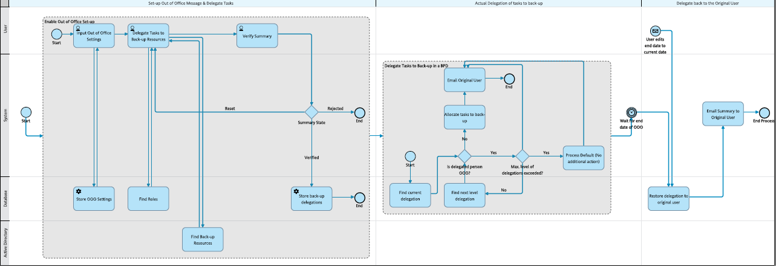

Figure 8 Expanded Process Model

# Details of activities in the Process Model

## 1. Set-up Out of Office Message & Delegate Tasks

### 1.1. Enable Out of Office Set-up

This activity enables a user to set-up the out-of-office configurations.

#### 1.1.1. Input Out of Office Settings

In this activity, a user inputs into a screen the start and end date and time of the duration he/she will be out of office. The user can also key in a message.

|  |  |  |
| --- | --- | --- |
|  |  |  |
|  | |  |  |  |  |  |  |  |  |  |  |  |  |  |  |  |  |  |  |  |  |  |  |  |  |  |  |  |  | | --- | --- | --- | --- | --- | --- | --- | --- | --- | --- | --- | --- | --- | --- | --- | --- | --- | --- | --- | --- | --- | --- | --- | --- | --- | --- | --- | --- | | |  |  |  |  |  |  |  |  |  |  |  |  |  |  |  |  |  |  |  |  |  |  |  |  |  |  |  | | --- | --- | --- | --- | --- | --- | --- | --- | --- | --- | --- | --- | --- | --- | --- | --- | --- | --- | --- | --- | --- | --- | --- | --- | --- | --- | --- | | |  | | --- | | **Participants** | | |  |  |  | | --- | --- | --- | | |  |  | | --- | --- | |  | User | | | | **Inputs** | | |  |  |  | | --- | --- | --- | | |  |  | | --- | --- | |  | User Id | | | | |  | | --- | | **Outputs** | | |  |  |  | | --- | --- | --- | | |  |  | | --- | --- | |  | Start date & time | | | |  | | |  |  |  | | --- | --- | --- | | |  |  | | --- | --- | |  | End date & time | | | |  | | |  |  |  | | --- | --- | --- | | |  |  | | --- | --- | |  | Out of Office Message | | | |   . | |  |
|  |  |  |

#### 1.1.2. Store OOO Settings

In this activity, the out-of-office settings from the step 'Input Out of Office Settings' are stored in the database.

|  |  |  |
| --- | --- | --- |
|  |  |  |
|  | |  |  |  |  |  |  |  |  |  |  |  |  |  | | --- | --- | --- | --- | --- | --- | --- | --- | --- | --- | --- | --- | --- | | |  |  |  |  |  |  |  |  |  |  |  |  | | --- | --- | --- | --- | --- | --- | --- | --- | --- | --- | --- | --- | | |  | | --- | | **Participants** | | |  |  |  | | --- | --- | --- | | |  |  | | --- | --- | |  | Database | | | | |  | | --- | | **Inputs** | | |  |  |  | | --- | --- | --- | | |  |  | | --- | --- | |  | User Id | | | |   . | |  |
|  |  |  |

#### 1.1.3. Delegate Tasks to Back-up Resources

If back-up resources are available, then the list of those resources are displayed for each role so that the user can delegate the tasks for a particular role to a particular back-up resource.

|  |  |  |
| --- | --- | --- |
|  |  |  |
|  | |  |  |  |  |  |  |  |  |  |  |  |  |  |  |  |  |  |  |  |  |  |  |  |  |  |  |  |  | | --- | --- | --- | --- | --- | --- | --- | --- | --- | --- | --- | --- | --- | --- | --- | --- | --- | --- | --- | --- | --- | --- | --- | --- | --- | --- | --- | --- | | |  |  |  |  |  |  |  |  |  |  |  |  |  |  |  |  |  |  |  |  |  |  |  |  |  |  |  | | --- | --- | --- | --- | --- | --- | --- | --- | --- | --- | --- | --- | --- | --- | --- | --- | --- | --- | --- | --- | --- | --- | --- | --- | --- | --- | --- | | |  | | --- | | **Participants** | | |  |  |  | | --- | --- | --- | | |  |  | | --- | --- | |  | User | | | | **Inputs** | | |  |  |  | | --- | --- | --- | | |  |  | | --- | --- | |  | User Id | | | |  | | |  |  |  | | --- | --- | --- | | |  |  | | --- | --- | |  | Current Roles | | | |  | | |  |  |  | | --- | --- | --- | | |  |  | | --- | --- | |  | Back-up Resource List for each Role | | | | |  | | --- | | **Outputs** | | |  |  |  | | --- | --- | --- | | |  |  | | --- | --- | |  | Back-up Resource for each Role | | | |   . | |  |
|  |  |  |

#### 1.1.4. Find Roles

This activity returns the current roles assigned to the user from the database.

|  |  |  |
| --- | --- | --- |
|  |  |  |
|  | |  |  |  |  |  |  |  |  |  |  |  |  |  |  |  |  |  |  | | --- | --- | --- | --- | --- | --- | --- | --- | --- | --- | --- | --- | --- | --- | --- | --- | --- | --- | | |  |  |  |  |  |  |  |  |  |  |  |  |  |  |  |  |  | | --- | --- | --- | --- | --- | --- | --- | --- | --- | --- | --- | --- | --- | --- | --- | --- | --- | | |  | | --- | | **Participants** | | |  |  |  | | --- | --- | --- | | |  |  | | --- | --- | |  | Database | | | | **Inputs** | | |  |  |  | | --- | --- | --- | | |  |  | | --- | --- | |  | User Id | | | | |  | | --- | | **Outputs** | | |  |  |  | | --- | --- | --- | | |  |  | | --- | --- | |  | Current Roles | | | |   . | |  |
|  |  |  |

#### 1.1.5. Verify Summary

This activity shows a summary of the current Out of Office delegation configurations.

|  |  |  |
| --- | --- | --- |
|  |  |  |
|  | |  |  |  |  |  |  |  |  |  |  |  |  |  |  |  |  |  |  |  |  |  |  |  |  |  |  |  |  |  |  |  |  |  | | --- | --- | --- | --- | --- | --- | --- | --- | --- | --- | --- | --- | --- | --- | --- | --- | --- | --- | --- | --- | --- | --- | --- | --- | --- | --- | --- | --- | --- | --- | --- | --- | --- | | |  |  |  |  |  |  |  |  |  |  |  |  |  |  |  |  |  |  |  |  |  |  |  |  |  |  |  |  |  |  |  |  | | --- | --- | --- | --- | --- | --- | --- | --- | --- | --- | --- | --- | --- | --- | --- | --- | --- | --- | --- | --- | --- | --- | --- | --- | --- | --- | --- | --- | --- | --- | --- | --- | | |  | | --- | | **Participants** | | |  |  |  | | --- | --- | --- | | |  |  | | --- | --- | |  | User | | | | **Inputs** | | |  |  |  | | --- | --- | --- | | |  |  | | --- | --- | |  | User Id | | | |  | | |  |  |  | | --- | --- | --- | | |  |  | | --- | --- | |  | Current Roles | | | |  | | |  |  |  | | --- | --- | --- | | |  |  | | --- | --- | |  | List of Back-up Resources | | | | |  | | --- | | **Outputs** | | |  |  |  | | --- | --- | --- | | |  |  | | --- | --- | |  | List of Selected Back-up Resources | | | |  | | |  |  |  | | --- | --- | --- | | |  |  | | --- | --- | |  | Submission Button Response | | | |   . | |  |
|  |  |  |

#### 1.1.6. Summary State

This gateway decides which path to take next based on the value of the field 'Submission Button Response'. If reset, the control goes back to the previous screens to select the back-up resources again; if verified the delegation details are stored in a database. If rejected, no action is needed i.e. no re-delegation details are saved.

#### 1.1.7. Store back-up delegations

Store the delegated resource as current delegation for each role as per the inputs from the step 'Verify Summary'.

|  |  |  |
| --- | --- | --- |
|  |  |  |
|  | |  |  |  |  |  |  |  |  |  |  |  |  |  |  |  |  |  |  | | --- | --- | --- | --- | --- | --- | --- | --- | --- | --- | --- | --- | --- | --- | --- | --- | --- | --- | | |  |  |  |  |  |  |  |  |  |  |  |  |  |  |  |  |  | | --- | --- | --- | --- | --- | --- | --- | --- | --- | --- | --- | --- | --- | --- | --- | --- | --- | | |  | | --- | | **Participants** | | |  |  |  | | --- | --- | --- | | |  |  | | --- | --- | |  | Database | | | | |  | | --- | | **Inputs** | | |  |  |  | | --- | --- | --- | | |  |  | | --- | --- | |  | Current Roles | | | |  | | |  |  |  | | --- | --- | --- | | |  |  | | --- | --- | |  | Back-up Resources for each Role | | | |   . | |  |
|  |  |  |

#### 1.1.8. Find Back-up Resources

This activity returns the list of users who can be back-ups for the user from an AD.

|  |  |  |
| --- | --- | --- |
|  |  |  |
|  | |  |  |  |  |  |  |  |  |  |  |  |  |  | | --- | --- | --- | --- | --- | --- | --- | --- | --- | --- | --- | --- | --- | | |  |  |  |  |  |  |  |  |  |  |  |  | | --- | --- | --- | --- | --- | --- | --- | --- | --- | --- | --- | --- | | |  | | --- | | **Participants** | | |  |  |  | | --- | --- | --- | | |  |  | | --- | --- | |  | Active Directory | | | | |  | | --- | | **Outputs** | | |  |  |  | | --- | --- | --- | | |  |  | | --- | --- | |  | List of Back-up Resources | | | |   . | |  |
|  |  |  |

## 2. Actual Delegation of tasks to back-up

### 2.1. Delegate Tasks to Back-up in a BPD

#### 2.1.1. Find current delegation

In a BPD, activity assignment needs to be checked from the current delegation stored in the database.

|  |  |  |
| --- | --- | --- |
|  |  |  |
|  | |  |  |  |  |  |  |  |  |  |  |  |  |  |  |  |  |  |  |  |  |  |  |  | | --- | --- | --- | --- | --- | --- | --- | --- | --- | --- | --- | --- | --- | --- | --- | --- | --- | --- | --- | --- | --- | --- | --- | | |  |  |  |  |  |  |  |  |  |  |  |  |  |  |  |  |  |  |  |  |  |  | | --- | --- | --- | --- | --- | --- | --- | --- | --- | --- | --- | --- | --- | --- | --- | --- | --- | --- | --- | --- | --- | --- | | |  | | --- | | **Participants** | | |  |  |  | | --- | --- | --- | | |  |  | | --- | --- | |  | Database | | | | **Inputs** | | |  |  |  | | --- | --- | --- | | |  |  | | --- | --- | |  | Role | | | | |  | | --- | | **Outputs** | | |  |  |  | | --- | --- | --- | | |  |  | | --- | --- | |  | Current Delegation | | | |  | | |  |  |  | | --- | --- | --- | | |  |  | | --- | --- | |  | Back-up Resource Availability | | | |   . | |  |
|  |  |  |

#### 2.1.2. Is delegated person OOO?

This gateway decides if the delegated person is also OOO based on the field 'Back-up Resource Availability'.

#### 2.1.3. Allocate tasks to back-up

Using the outputs from the step 'Find current delegation', current tasks are allocated to the correct user.

|  |  |  |
| --- | --- | --- |
|  |  |  |
|  | |  |  |  |  |  |  |  |  |  |  |  |  |  | | --- | --- | --- | --- | --- | --- | --- | --- | --- | --- | --- | --- | --- | | |  |  |  |  |  |  |  |  |  |  |  |  | | --- | --- | --- | --- | --- | --- | --- | --- | --- | --- | --- | --- | | |  | | --- | | **Participants** | | |  |  |  | | --- | --- | --- | | |  |  | | --- | --- | |  | System | | | | |  | | --- | | **Inputs** | | |  |  |  | | --- | --- | --- | | |  |  | | --- | --- | |  | Current Delegation | | | |   . | |  |
|  |  |  |

#### 2.1.4. Email Original User

This activity sends an email notification to the original task owner regarding the re-assignment of tasks.

|  |  |  |
| --- | --- | --- |
|  |  |  |
|  | |  |  |  |  |  |  |  |  | | --- | --- | --- | --- | --- | --- | --- | --- | | |  |  |  |  |  |  |  | | --- | --- | --- | --- | --- | --- | --- | | |  | | --- | | **Participants** | | |  |  |  | | --- | --- | --- | | |  |  | | --- | --- | |  | System | | | |  |   . | |  |
|  |  |  |

#### 2.1.5. Max. level of delegations exceeded?

This gateway decides which path to take based on the pre-configured maximum no. of allowed forward delegations. If this is exceeded, no action is needed as the process defaults apply. Else the next level back-up resource is to be found from the database.

#### 2.1.6. Process Default (No additional action)

No delegation action is taken by the system and the handling of the task falls through to the designed workflow.

|  |  |  |
| --- | --- | --- |
|  |  |  |
|  | |  |  |  |  |  |  |  |  | | --- | --- | --- | --- | --- | --- | --- | --- | | |  |  |  |  |  |  |  | | --- | --- | --- | --- | --- | --- | --- | | |  | | --- | | **Participants** | | |  |  |  | | --- | --- | --- | | |  |  | | --- | --- | |  | System | | | |  |   . | |  |
|  |  |  |

#### 2.1.7. Find next level delegation

If the person to whom the task has been re-delegated is also out of office the task has to be assigned to his or her back-up. This activity gets the next level back-up resource from the database.

|  |  |  |
| --- | --- | --- |
|  |  |  |
|  | |  |  |  |  |  |  |  |  |  |  |  |  |  |  |  |  |  |  |  |  |  |  |  | | --- | --- | --- | --- | --- | --- | --- | --- | --- | --- | --- | --- | --- | --- | --- | --- | --- | --- | --- | --- | --- | --- | --- | | |  |  |  |  |  |  |  |  |  |  |  |  |  |  |  |  |  |  |  |  |  |  | | --- | --- | --- | --- | --- | --- | --- | --- | --- | --- | --- | --- | --- | --- | --- | --- | --- | --- | --- | --- | --- | --- | | |  | | --- | | **Participants** | | |  |  |  | | --- | --- | --- | | |  |  | | --- | --- | |  | Database | | | | **Inputs** | | |  |  |  | | --- | --- | --- | | |  |  | | --- | --- | |  | Role | | | | |  | | --- | | **Outputs** | | |  |  |  | | --- | --- | --- | | |  |  | | --- | --- | |  | Current Delegation | | | |  | | |  |  |  | | --- | --- | --- | | |  |  | | --- | --- | |  | Back-up Resource Availability | | | |   . | |  |
|  |  |  |

### 2.2. Wait for end date of OOO

The process waits here for the end date and time of the Out of Office configurations to approach.

## 3. Delegate back to the Original User

### 3.1. Restore delegation to original user

At the end date and time of the Out of Office duration, this step restores the delegations to the original user.

|  |  |  |
| --- | --- | --- |
|  |  |  |
|  | |  |  |  |  |  |  |  |  |  |  |  |  |  |  |  |  |  |  | | --- | --- | --- | --- | --- | --- | --- | --- | --- | --- | --- | --- | --- | --- | --- | --- | --- | --- | | |  |  |  |  |  |  |  |  |  |  |  |  |  |  |  |  |  | | --- | --- | --- | --- | --- | --- | --- | --- | --- | --- | --- | --- | --- | --- | --- | --- | --- | | |  | | --- | | **Participants** | | |  |  |  | | --- | --- | --- | | |  |  | | --- | --- | |  | Database | | | | |  | | --- | | **Inputs** | | |  |  |  | | --- | --- | --- | | |  |  | | --- | --- | |  | Current Roles | | | |  | | |  |  |  | | --- | --- | --- | | |  |  | | --- | --- | |  | User Id | | | |   . | |  |
|  |  |  |

### 3.2. Email Summary to Original User

This activity sends an email notification to the original task owner with the summary of the re-assignment of tasks.

|  |  |  |
| --- | --- | --- |
|  |  |  |
|  | |  |  |  |  |  |  |  |  | | --- | --- | --- | --- | --- | --- | --- | --- | | |  |  |  |  |  |  |  | | --- | --- | --- | --- | --- | --- | --- | | |  | | --- | | **Participants** | | |  |  |  | | --- | --- | --- | | |  |  | | --- | --- | |  | System | | | |  |   . | |  |
|  |  |  |

### 3.3. User edits end date to current date

In case the user decides to edit the end date and time of the out of office configurations, an alternate start to the process is triggered which directly goes to the step to restore the original delegations to the user.

# Glossary

## Participants, Business Owners, Experts

|  |  |
| --- | --- |
| **Value** | **Description** |
| Database | Database server to store the configurations and other process related data |
| Active Directory | Directory which stores list of users |
| System | BPM System |
| User | User who needs to set-up Out of Office configurations |

## Inputs, Outputs

|  |  |
| --- | --- |
| **Value** | **Description** |
| Back-up Resource Availability | This field tells if a back-up resource is available or out-of-office |
| List of Selected Back-up Resources | The back-up resources who are selected to delegate the tasks assigned to the role |
| Back-up Resource List for each Role | List of back-up resources who can perform the tasks assigned to the role |
| Current Delegation | The user to whom the tasks for a particular role is currently assigned (could be the original user or the selected back-up user) |
| Current Roles | Current roles assigned to the original user |
| End date & time | End date and time of the duration when the user is going to be Out of Office |
| Out of Office Message | Message left by the user to be displayed during the period when the user is going to be Out of Office |
| Role | A particular role used to implement a particular activity |
| Start date & time | Start date and time of the duration when the user is going to be Out of Office |
| User Id | User Identification for the original user who intends to set up out of office configurations. |